**Pre-Lab 4:**

**Operational Amplifiers – Part II**

Name: Wan-Yu Liao

ECEN 325 Section 514

TA: Mandela

Date: September 27, 2019

**Calculations**

(1)



(2)



(3)



(4)



**Simulations**

**Circuit 1:**

(a)

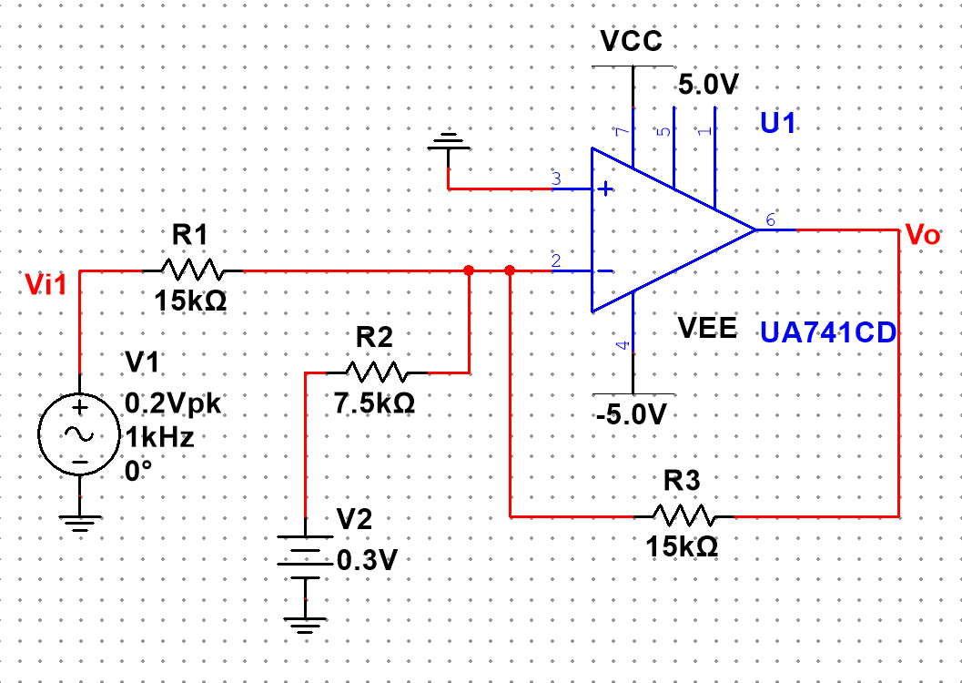

(b)

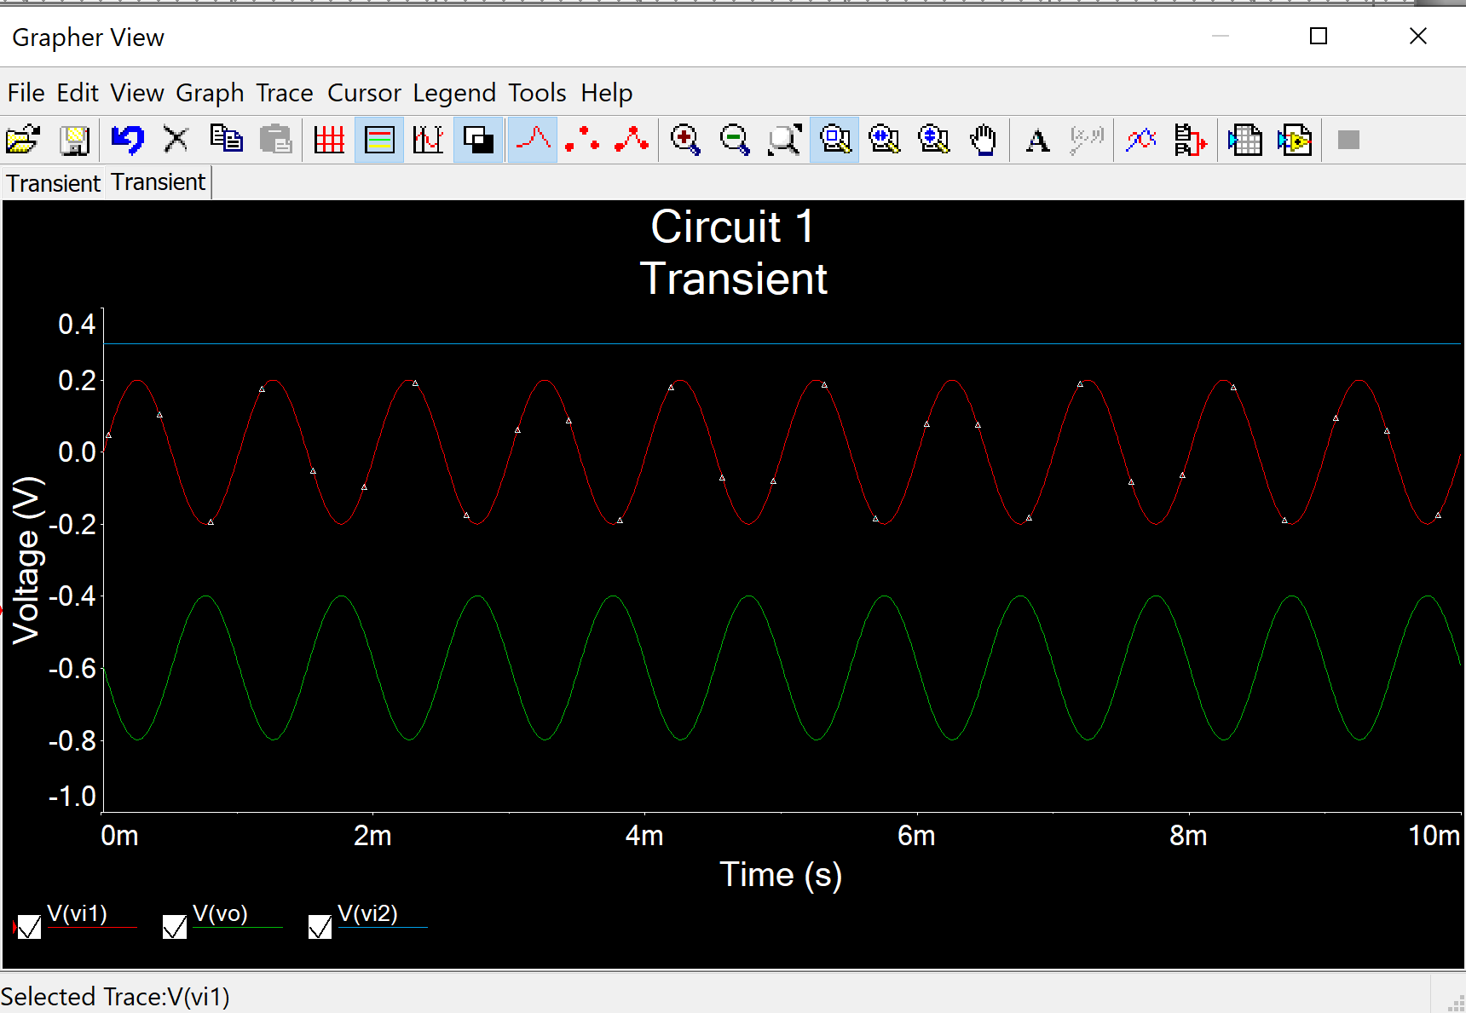

$$V_{i1}=0.2\sin\left(2Π1000t\right)$$

$v_{0}=-0.2\sin\left(2Π1000t\right)-0.6$, which is opposite the Vi1 and shift down by 0.6.

**Circuit 2:**

(a)

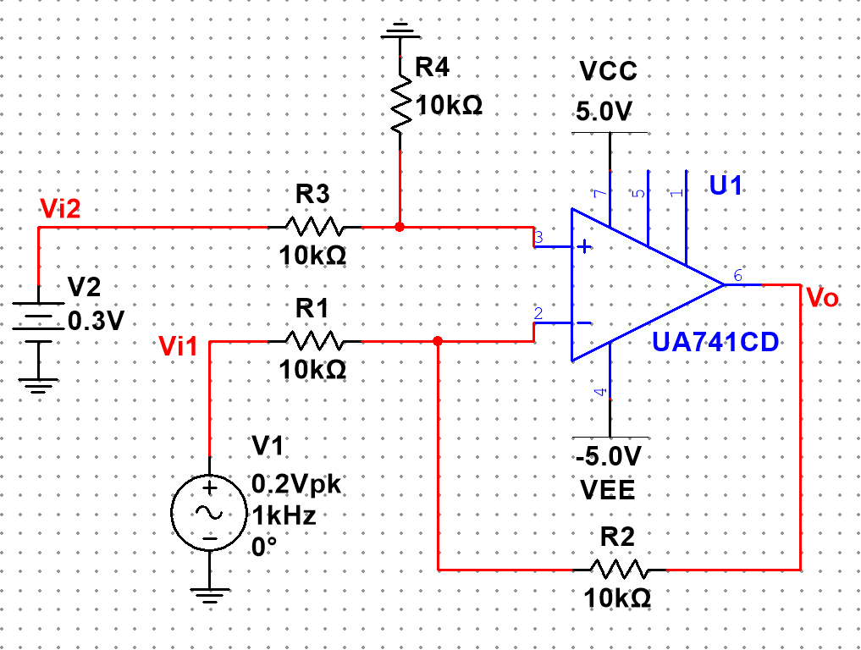

(b)

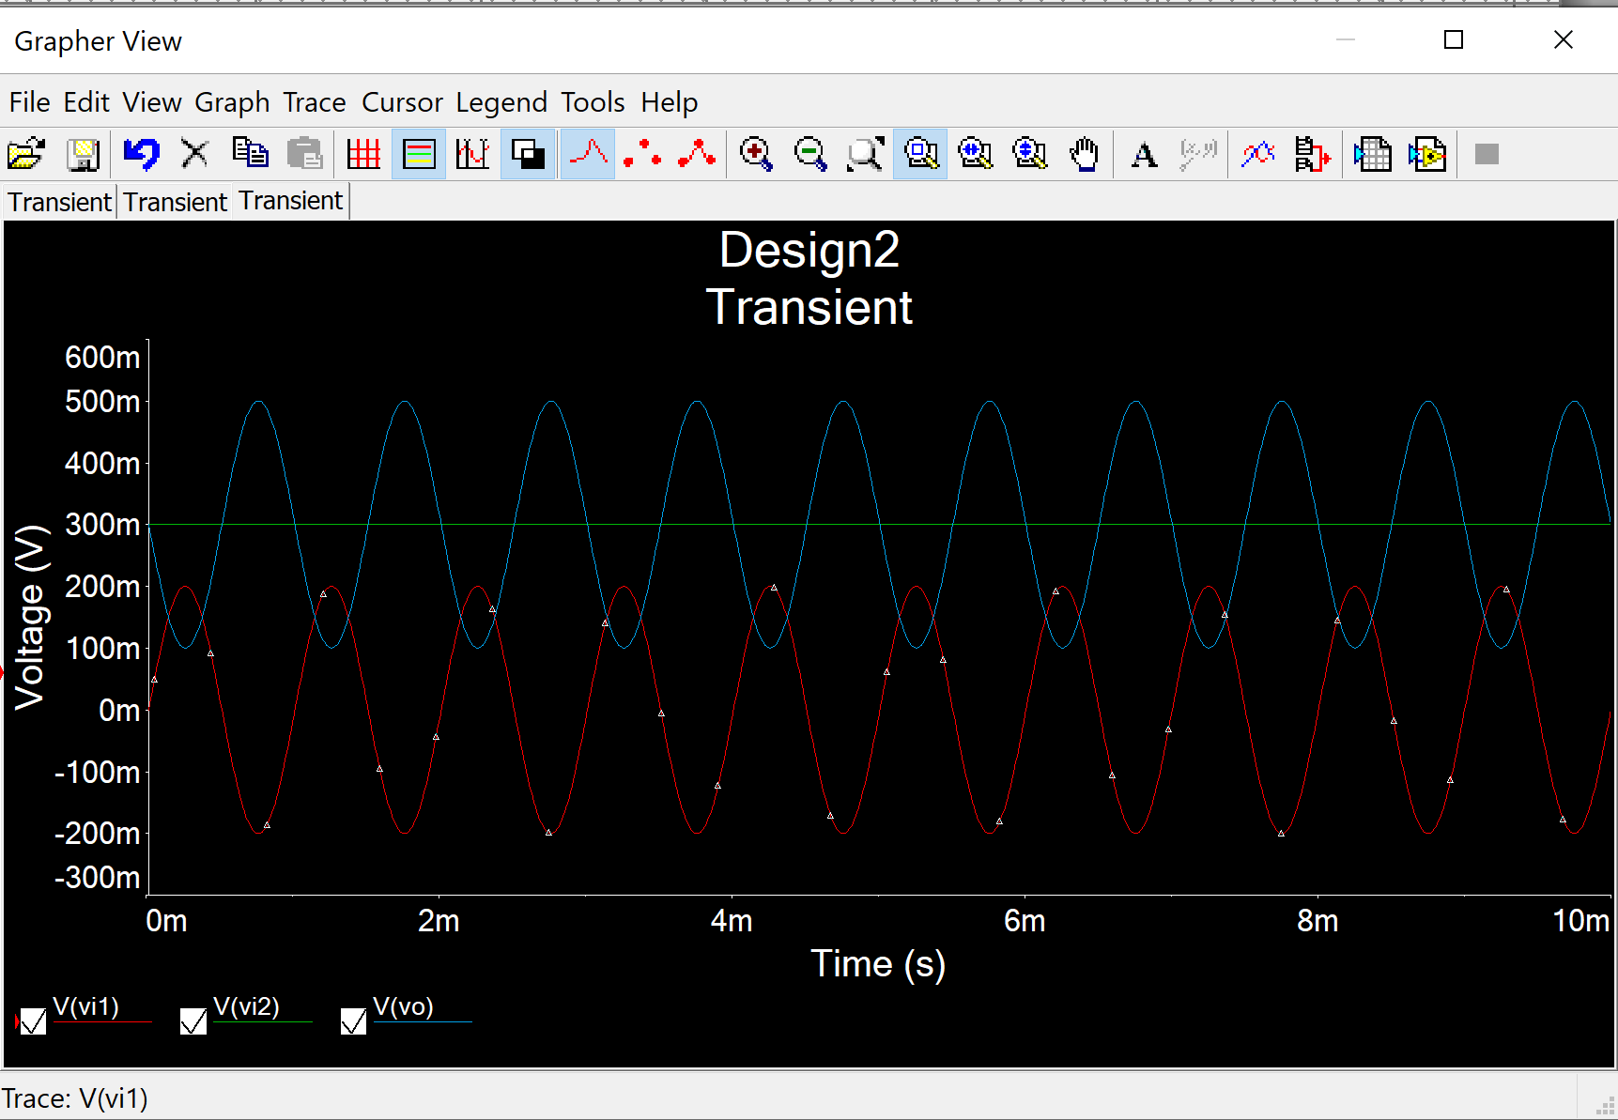

$$V_{i1}=0.2\sin\left(2Π1000t\right)$$

$v_{0}=-0.2\sin\left(2Π1000t\right)+0.3$, which is opposite the Vi1 and shift up by 0.3.

**Circuit 3:**

(a)

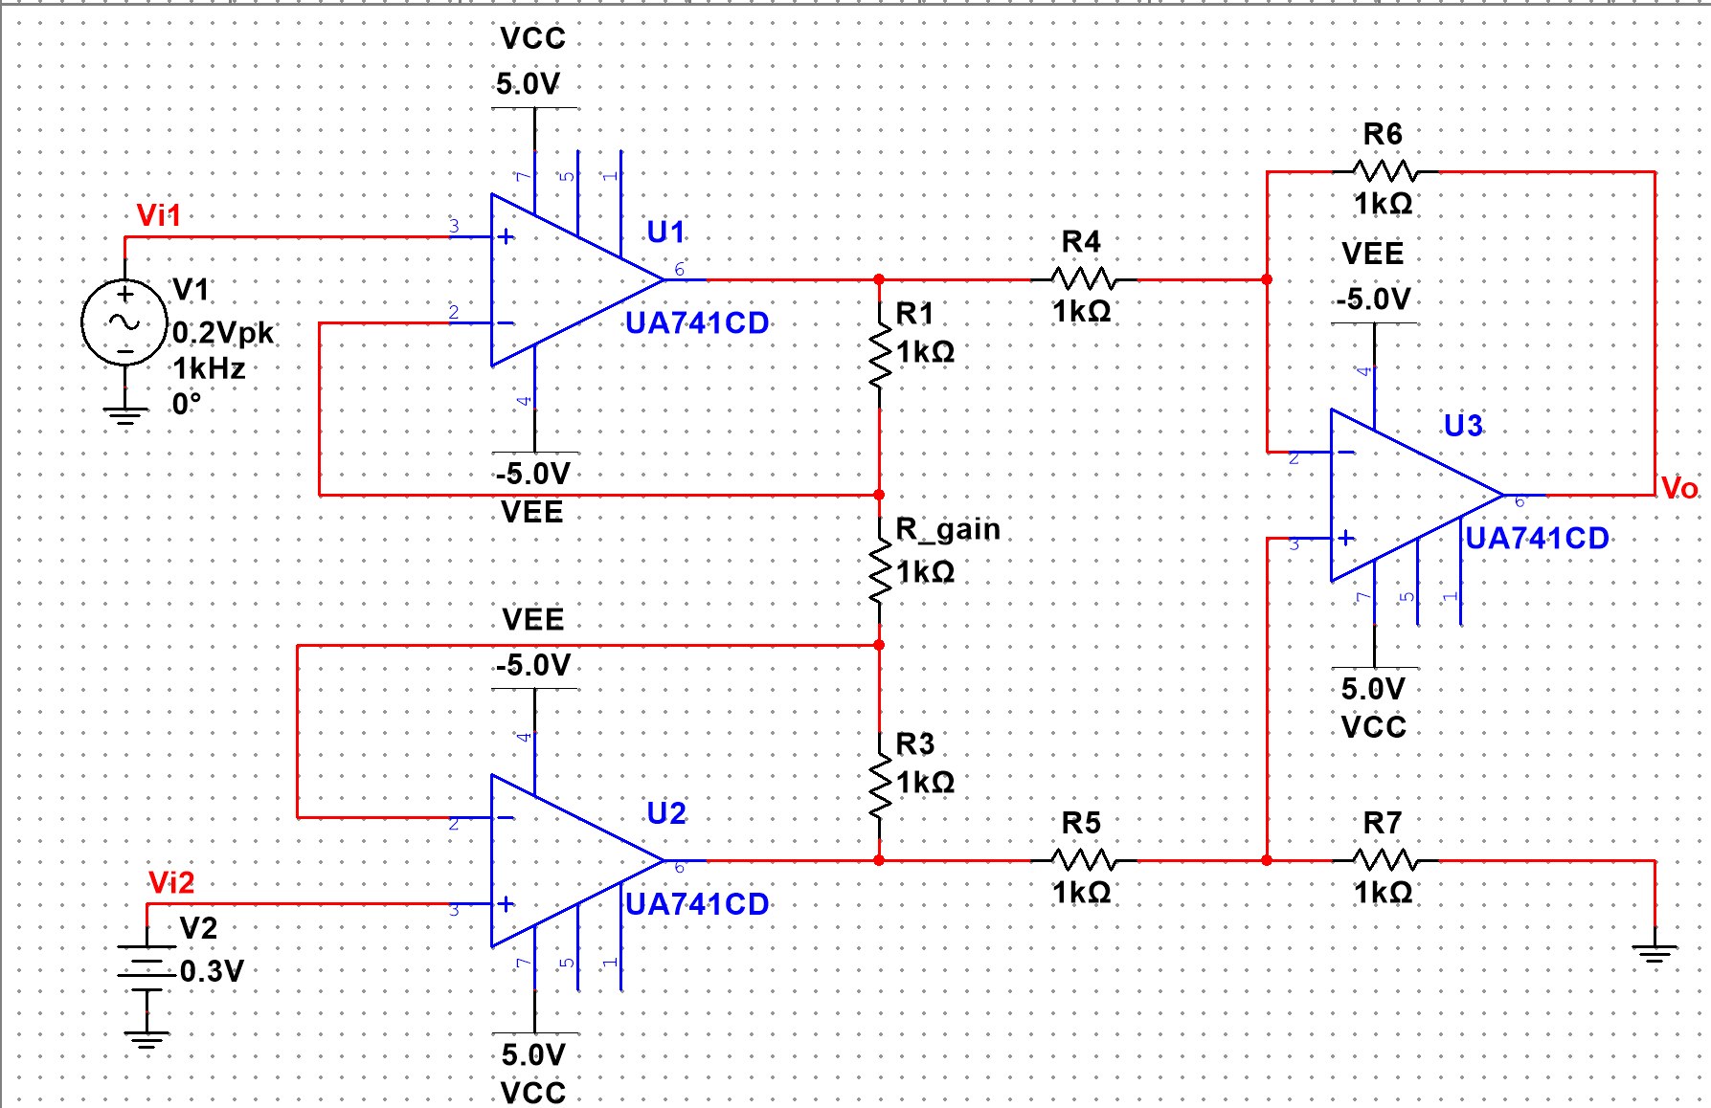

(b)

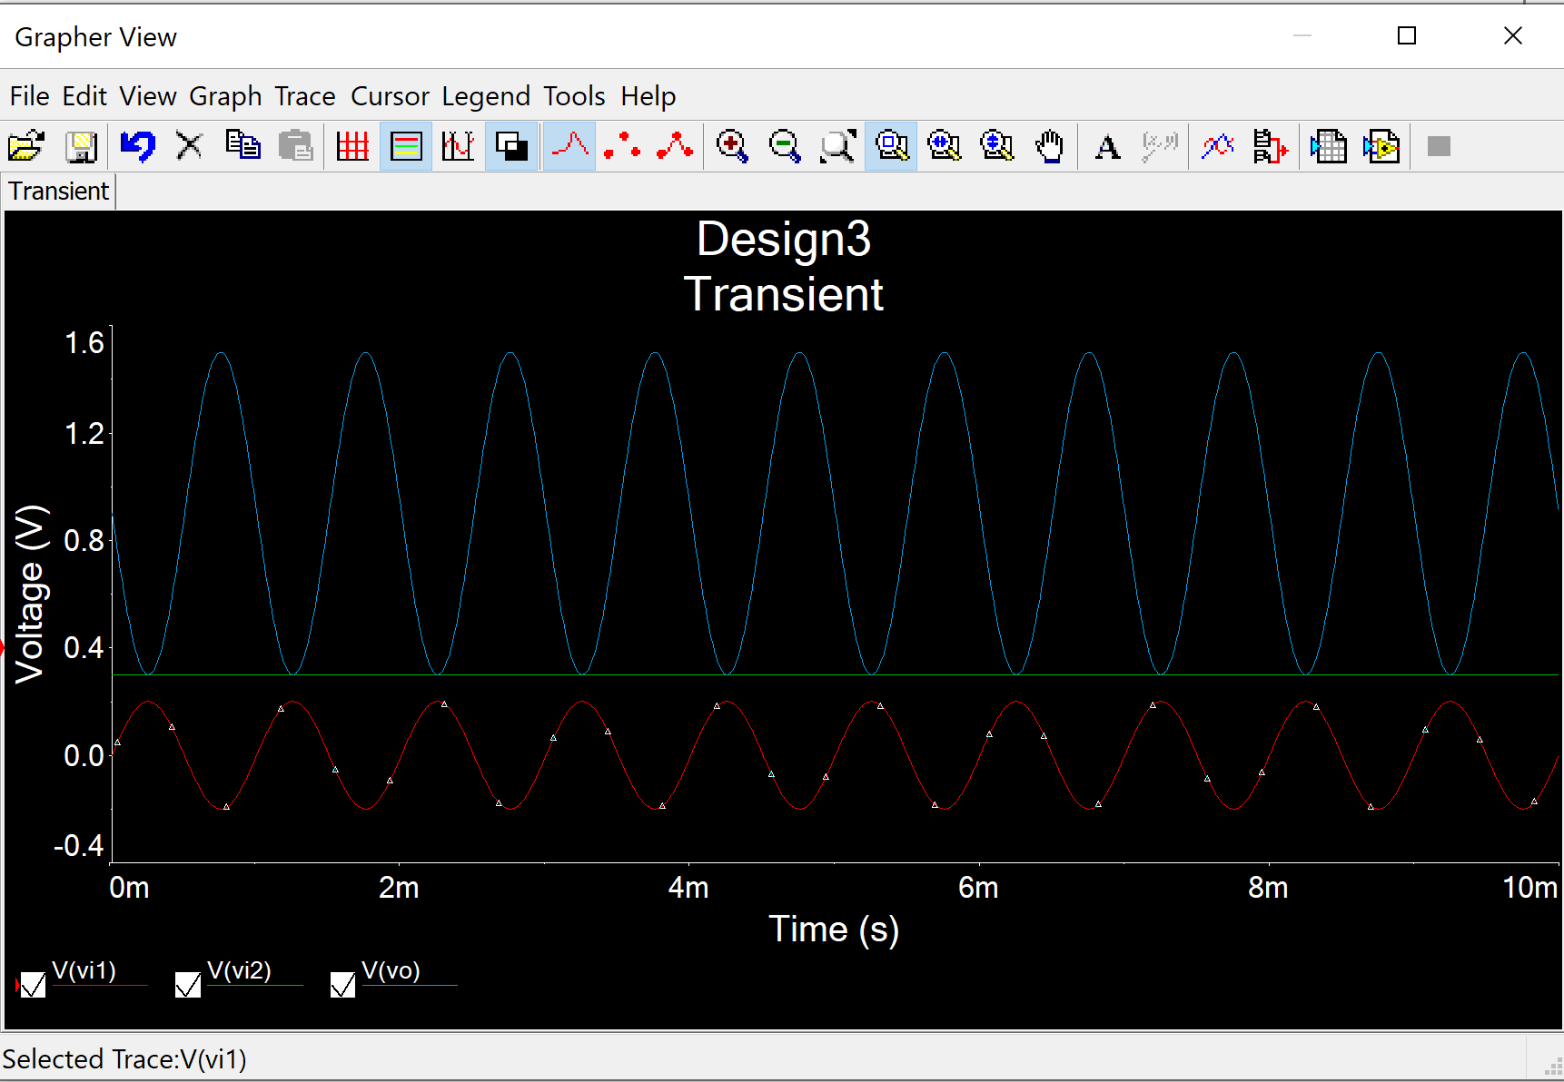

$$V_{i1}=0.2\sin\left(2Π1000t\right)$$

$v_{0}=-0.6\sin\left(2Π1000t\right)+0.9$

which is opposite the Vi1 with amplitude of 0.6 and shift up by 0.9.